Cisco Innovation Labs Tiger Team Execution Summary

Cisco Innovation Lab: FSO Offer Demo

**Author(s):**

Keshav Kumar, Software Engineering Technical Leader, keskuma2@cisco.com

Cody Hartsook, Software Engineer, chartsoo@cisco.com

**Contributors:**

Toshihiro Imai, Solutions Architect, timai@cisco.com

Cody Hartsook, Software Engineer, chartsoo@cisco.com

Lucas Barboza, Solutions Architect, lmendesb@cisco.com

Leandro Schwab Dias Carneiro, Software Engineer, lschwabd@cisco.com

Brianna Gilchrist, Software Engineer, brgilchr@cisco.com

Keshav Kumar, Software Engineering Technical Leader, [keskuma2@cisco.com](mailto:keskuma2@cisco.com)

Felix Kaechele, Engineering Technical Leader, [fkaechel@cisco.com](mailto:fkaechel@cisco.com)

**Revisions:**

0.01 First Draft 02/02/2023

**Related Project(s) and Tracking:**

[links](http://siggy.cisco.com/project-tracker/projects/507226)

**Cisco Confidential**

This document contains valuable trade secrets and confidential information belonging to Cisco Systems, Inc., and its suppliers. They shall not be disclosed to any person, organization, or entity, unless such disclosure is subject to the provisions of a written non-disclosure and proprietary rights agreement, or intellectual property license agreement, approved by Cisco Systems, Inc. The distribution of this document does not grant any license or rights, in whole or in part, to its content, the product(s), the technology(s), or intellectual property, described herein. Third-party trademarks mentioned are the property of their respective owners. The use of the word partner does not imply a partnership relationship between Cisco and any other company.

EXECUTIVE SUMMARY

Cisco Full-Stack Observability provides visibility, insights, and actions delivered with correlated business context to maximize business value. Observability telemetry enables cross-domain teams to correlate performance metrics with business impact.

FSO at Cisco is defined by three primary pillars: visibility, insights, and actions. Our further understanding of the landscape is as follows:

* Our approach to Full-Stack Observability builds on continuous and tightly integrated monitoring.
* We provide Visibility, Insights and Actions across the Full Stack, from the API all the way to the bare metal, across all data types.
* We do this for traditional and cloud native applications and across hybrid and multi cloud environments.
* We acknowledge that 95% of our customers have a mix of the traditional and cloud native apps and we support these use cases.
* We tie our insights back to the business context: customers can know there is a problem, why the problem occurred and what to tackle immediately.
* We help optimize for performance, cost, security, and environmental impact (carbon intensity).

GOALS

Our take on creating an Innovation Labs FSO Experience for customers and developers is to be delivered in phases.

* Phase 1 – Customize the Open Telemetry Demo (Astronomy Shop microservice application) with Cisco Innovation Labs Branding (CIL logo, CIL custom components, Magnetic design system). This will serve as part of the presentation layer of the demo. Review it with AppDynamics (AppD), ThousandEyes and Intersight Workload Optimizer team.
* Phase 2 – Run Demo on multi cluster setup and run all 3 FSO tools or a use-case specific combination of FSO tools.
* Phase 3 – Inject manual faults or random faults and show its impact and related nonobvious scenario features. Show Demo App to Partner and Sales teams.
* Phase 4 – Integrate demo with chaos engineering. Trial the Demo with a minimum of 2 key Enterprise customers and 1 Partner globally to validate and iterate the design.  Build Advanced use case.

FUTURE COOLNESS

Currently we achieve observability of infrastructure and workloads via Intersight with hybrid-cloud infrastructure monitoring, observability and insights on applications and business logic via AppDynamics, and visibility and insights on network infrastructure and transit via ThousandEyes. There is no single pane of glass or aggregated view of all tools together. Tying together all sources from our FSO stack we can investigate providing actionable metrics that reflect the broader state of our infrastructure and how it impacts our business performance and cost structure. Integration with and Cisco’s commitment to industry and community efforts like Open Telemetry help to position us as a leader in the space that shapes the future of FSO for the broader Cloud Native ecosystem. As a result, our proprietary solutions integrate well with the rest of the ecosystem and do not feel like foreign matter.

Through a possible future version of the demo we can illustrate the use of Chaos Engineering (essentially the Cloud Native infrastructure equivalent of what Fuzzing is to Application Security) to determine performance of a distributed system and showcase the value of the insights generated by our FSO tooling.

CONTENT  
Cisco’s FSO solution is comprised of multiple products:  
AppDynamics, ThousandEyes, Intersight Workload Optimizer and Cisco Secure Application. It provides full-stack observability of infrastructure performance which supports all use cases.

**AppD**  
 Cisco (AppDynamics) has strong functionality for monitoring and analyzing complete user journeys, using AppDynamics Business iQ and Experience Journey Maps. This helps operations teams prioritize responses based on business impact and UX. Cisco (AppDynamics) also has a strong security product, Cisco Secure Application. It can provide operations and security teams with visibility into application vulnerabilities and threats for better joint risk assessment and enforcement, with alignment across security operations and ITOps/DevOps teams. The analytics built on the platform generates dashboards for analysis of business performance with application performance.

**Cisco IWO**   
 Continuous real-time application performance assurance at the lowest possible cost while maintaining business policies. Only solution for Application Resource Management capable of assuring real-time application performance at scale in a hybrid cloud environment. Integration with Cisco AppD for application visibility for full stack telemetry. IWO cloud differentiators: Application awareness (Including APM integration); Solution for hybrid cloud multicloud, on-premises, and cloud migrations; Automatable / Trustworthy Actions; Integration with ITSM workflow, IaC or CI/CD pipeline; Plan and optimize container sizing – Namespace, Nodes, Pods; Elastic Infrastructure – Pay for only what you need; SLO adherence scaling

**Thousand eyes**

Capabilities are unique in terms of digital experience monitoring and network performance monitoring, making it one of the unique products that can be used to provide root cause analysis for external triggers or WAN dependencies.

ThousandEyes solution consists of four major components:

● SaaS Platform installed and operated in our secure data center and/or IaaS, which includes the Web platform and several other services

● Enterprise Agent installed in the customer network

● Cloud Agent installed in hosting providers’ and ISP’s networks and managed by ThousandEyes

● Endpoint Agent installed on end-user computers within a customer’s organizatio

CURRENT LANDSCAPE

|  |  |  |  |
| --- | --- | --- | --- |
| Performance | Hybrid Application Monitoring | Visibility | AppDynamics |
| Modern (Cloud Native) Application Monitoring | Visibility | AppDynamics |
| Customer Digital Experience Monitoring | Insights, Action | AppDynamics, ThousandEyes |
| Application Dependency Monitoring | Insights, Action | AppDynamics, ThousandEyes |
| Optimization | Hybrid Cost Optimization | Insights, Action | AppDynamics, Intersight Workload Optimizer |
| Application Resource Optimization | Insights, Action | Intersight Workload Optimizer Intersight Infrastructure Service, |
| Security | Application Security | Visibility | AppDynamics Secure Applications, ThousandEyes |
| Cloud-Native Application Security | Insights, Action | Panoptica |
| Orchestration | Service Mesh Manager | Visibility | Calisti |
|  |  |  |  |

Customers are looking to move from monitoring to full-stack observability for the following reasons:

* Traditional IT environments are already extremely complex landscapes and how our customers’ applications perform are critical.
* We hear from our customers that they struggle with visibility up and down the stack across managed and unmanaged services.
* It’s also beyond human scale now to monitor everything that impacts their applications due to complexity.
* What this means is DevOps & AppOps, NetOps, InfraOps and SecOps teams need to be able to work together to utilize information from across domains and evaluating the interactions between them to fully understand the impact of one on the other.
* In the context of diagnosing and troubleshooting outages and service degradations we typically refer to this as the **Mean Time to Innocence**, with FSO enabling proactive mitigation of issues and helping these teams collaborate and manage events with ease and efficiency.

|  |
| --- |
| **TOP 4 WIN STRATEGIES** |
| * **BusinessContext** Lead with Cisco’s ability to provide [**Business iQ and business context**](https://salesconnect.cisco.com/#/content-detail/95c59500-1a7e-4e17-86fc-940b9d1d3cfe) giving customers the ability to extract, correlate and baseline business outcomes from application performance. |
| * **OutsideInMonitoring** [**Demo**](https://salesconnect.cisco.com/#/content-detail/4b05d407-1581-4db7-bd45-64ac694c1efb) the right use cases focused on end point monitoring and not RUM and Synthetics as this what makes Cisco unique in that domain. |
| * **FullStackObservabilitySevenUseCases** Focus on the seven use cases outlined in the[**FSO TDM**](https://salesconnect.cisco.com/#/content-detail/8ccaaa7e-1461-485c-b4d0-74c9b46f0685), and position these at a CxO level, selling the benefits of the solutions. If your customer has invested heavily in an APM or cloud tooling then insert one or two of the three products, we can then use our footprint to elevate the conversation. Lean on the SAP integration within AppD as other than Cisco and New Relic, no APM competitor can provide it. |
| * **Visibility,Insight&Action** [**Focus on the Visibility, Insights, and Actions framework**](https://salesconnect.cisco.com/#/content-detail/95c59500-1a7e-4e17-86fc-940b9d1d3cfe). IWO provides real action based on contextual insights which helps reducing MTTR, increasing uptime, and better user experience. Focus on automation of the workloads in a multi-cloud world and our ability to block security threats in the runtime of the code. |

OBJECTIVE

Develop and instrument a multi-cloud and edge application with multi-stage fault injection. This demo application can act as the foundation for FSO hands-on demos, labs, and trainings. The demo strives to be delivered as a fully instrumented, self-contained solution that is both replicable and easy to set up for experimentation and demonstration purposes. This delivers on the Innovation Labs’ premise of building real world experiences that customers and developers can kick the tires on.

USER STORIES

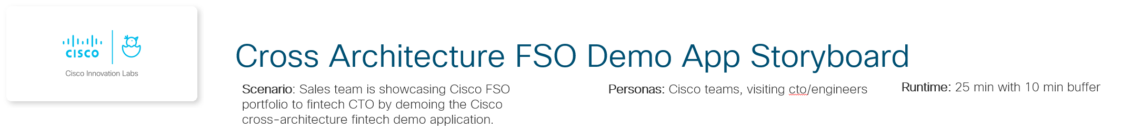

**Key talking points:**

Demo app includes FSO entrypoints/integrations on each hosting environment. Can demo full transaction lifecycle visibility.

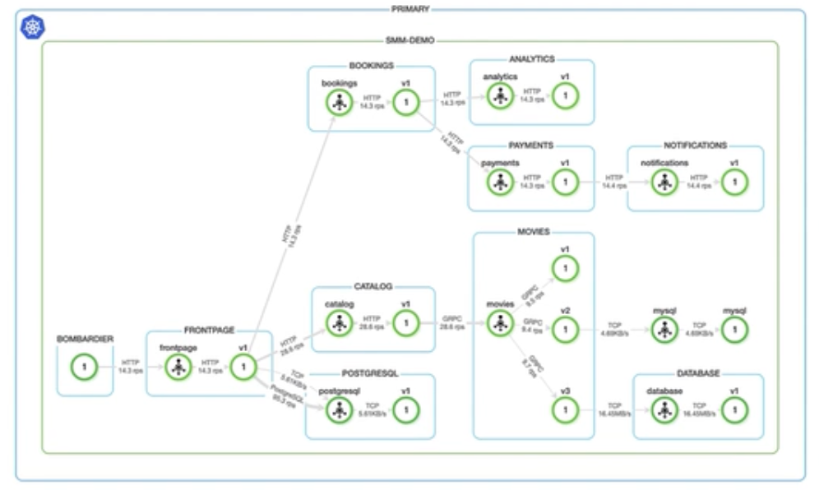

**1. Mobile-app: CTO is curious to see how Cisco FSO tools can improve her application's availability and performance. Cisco team launches the demo app to begin.**

**2. Cloud: Cisco team showcases cloud application visibility via OpenTelemetry and optional integration with AppDynamics.**

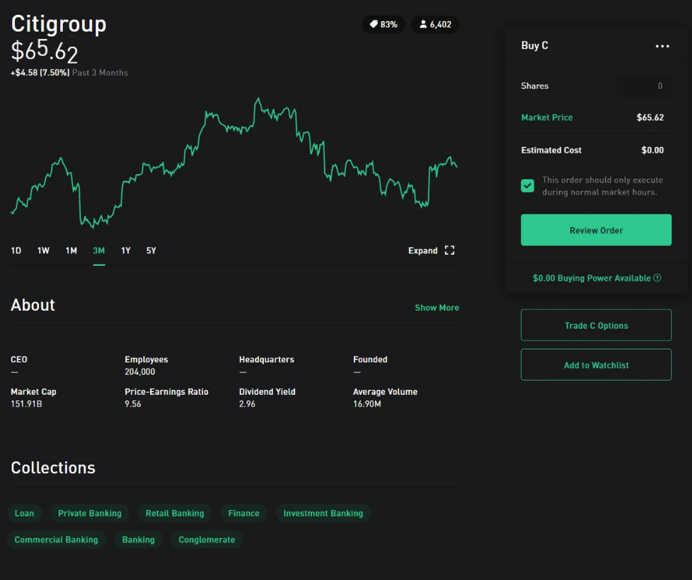

**Key talking points:**

OpenTelemetry instrumentation provides cloud components trace visibility and enhanced insights via AppDynamics.



**3. On-Prem: Cisco team demos on-prem visibility enabled by Open-Telemetry instrumentation.**

**4. Fault-Injection: Cisco team demos the ability to inject faults into the system.**

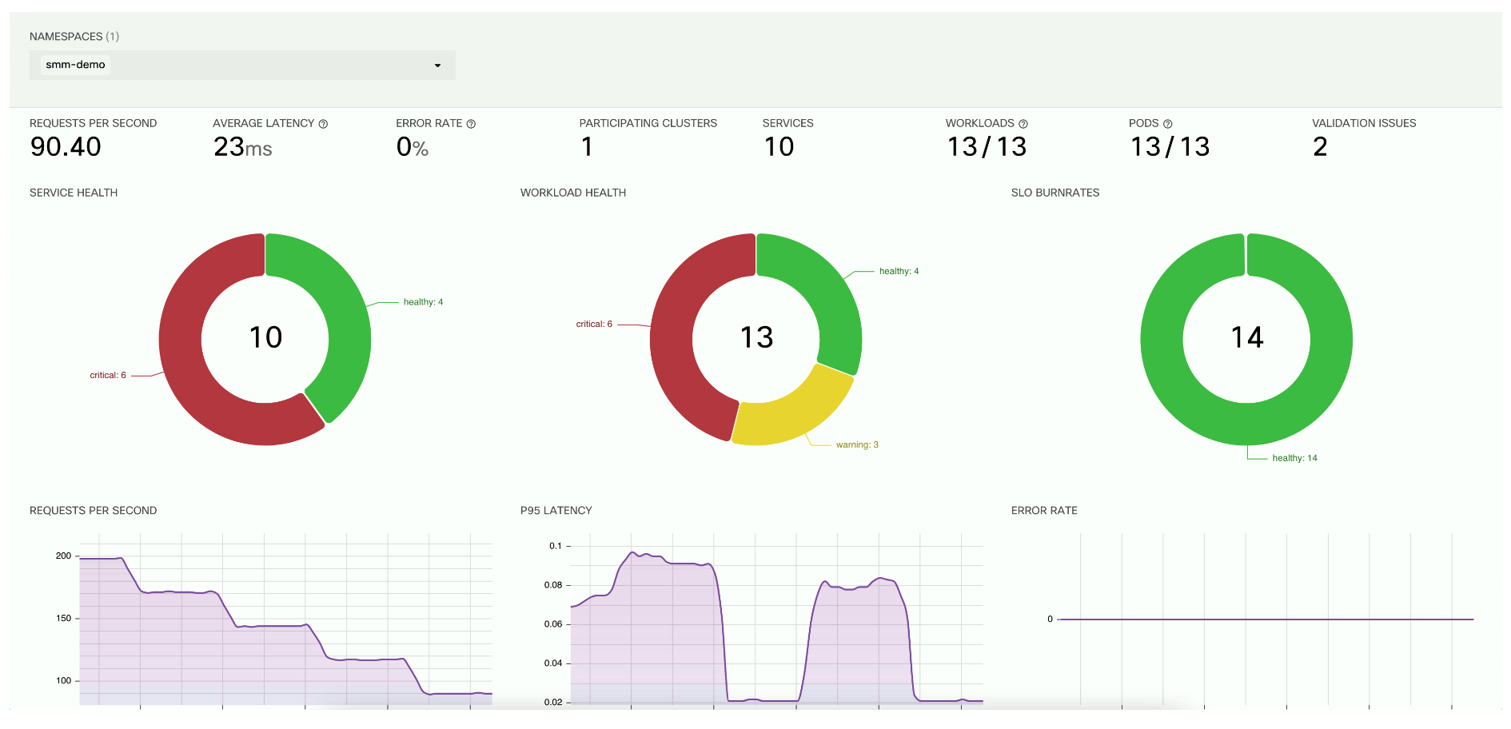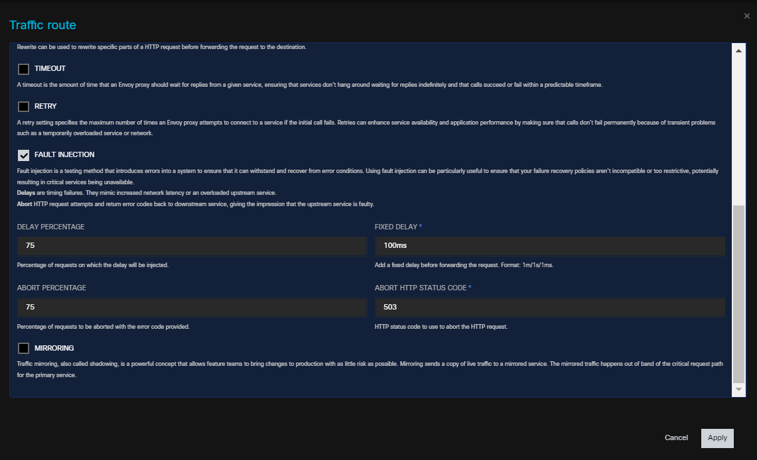

**Key talking points:**

Context propagation via OpenTelemetry instrumentation enables request tracing from cloud to on-prem services.

**Key talking points:**

Demo app includes programable fault injections, creating relevant troubleshooting scenarios.

Fault injections can train teams to quickly detect and remediate issues via FSO tools.

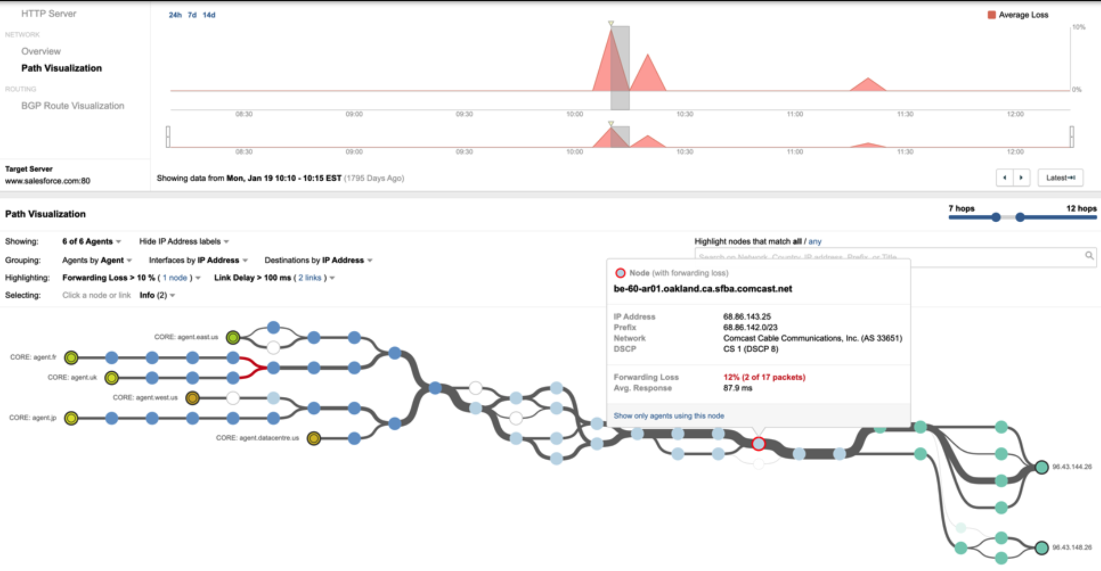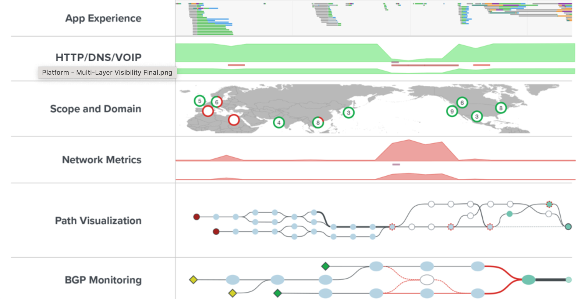

**5. Mobile-app network troubleshooting: Cisco team utilize integrated remote Thousand-Eyes to rule-out network issues.**

**6. Hybrid cloud network troubleshooting: Cisco team utilize integrated Thousand-Eyes cloud agents to rule-out network issues.**

**Key talking points:**

ThousandEyes network tracing and visibility can detect any latency or loss issues between the user and cloud.

**Key talking points:**

Cloud and on-prem ThousandEyes agents can monitor peering status and detect network anomalies.

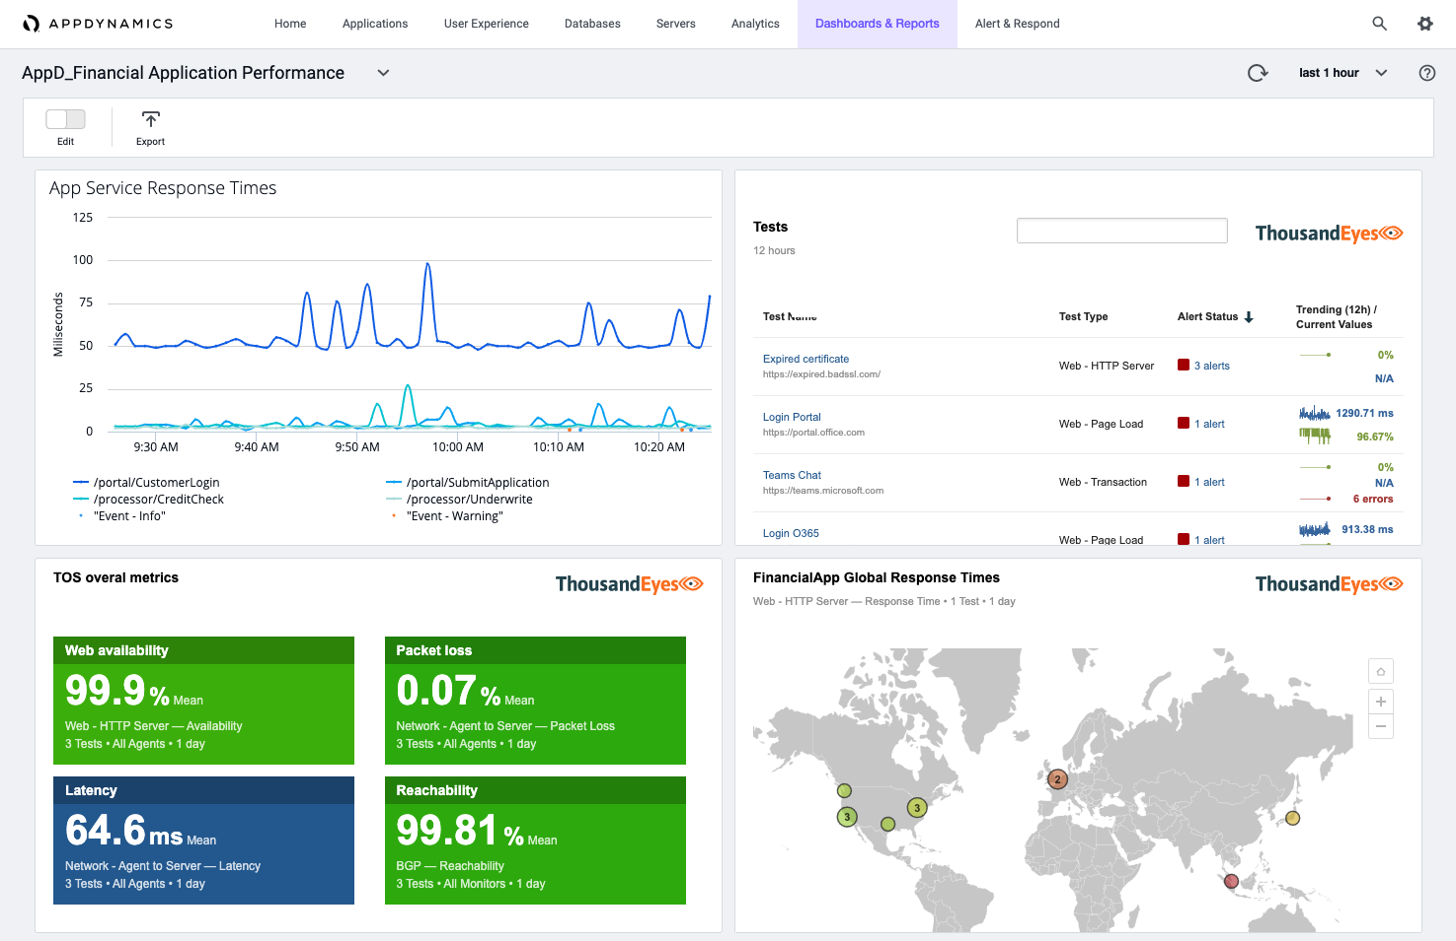

**7. Distributed trace analysis: Cisco team utilize OpenTelemetry distributed tracing and AppDynamics to detect the root cause.**

**Key talking points:**

Utilizing OpenTelemetry tracing and metrics, AppDynamics detects which services have been affected by the fault and can isolate the root cause.

System Architecture of Various FSO Tools:

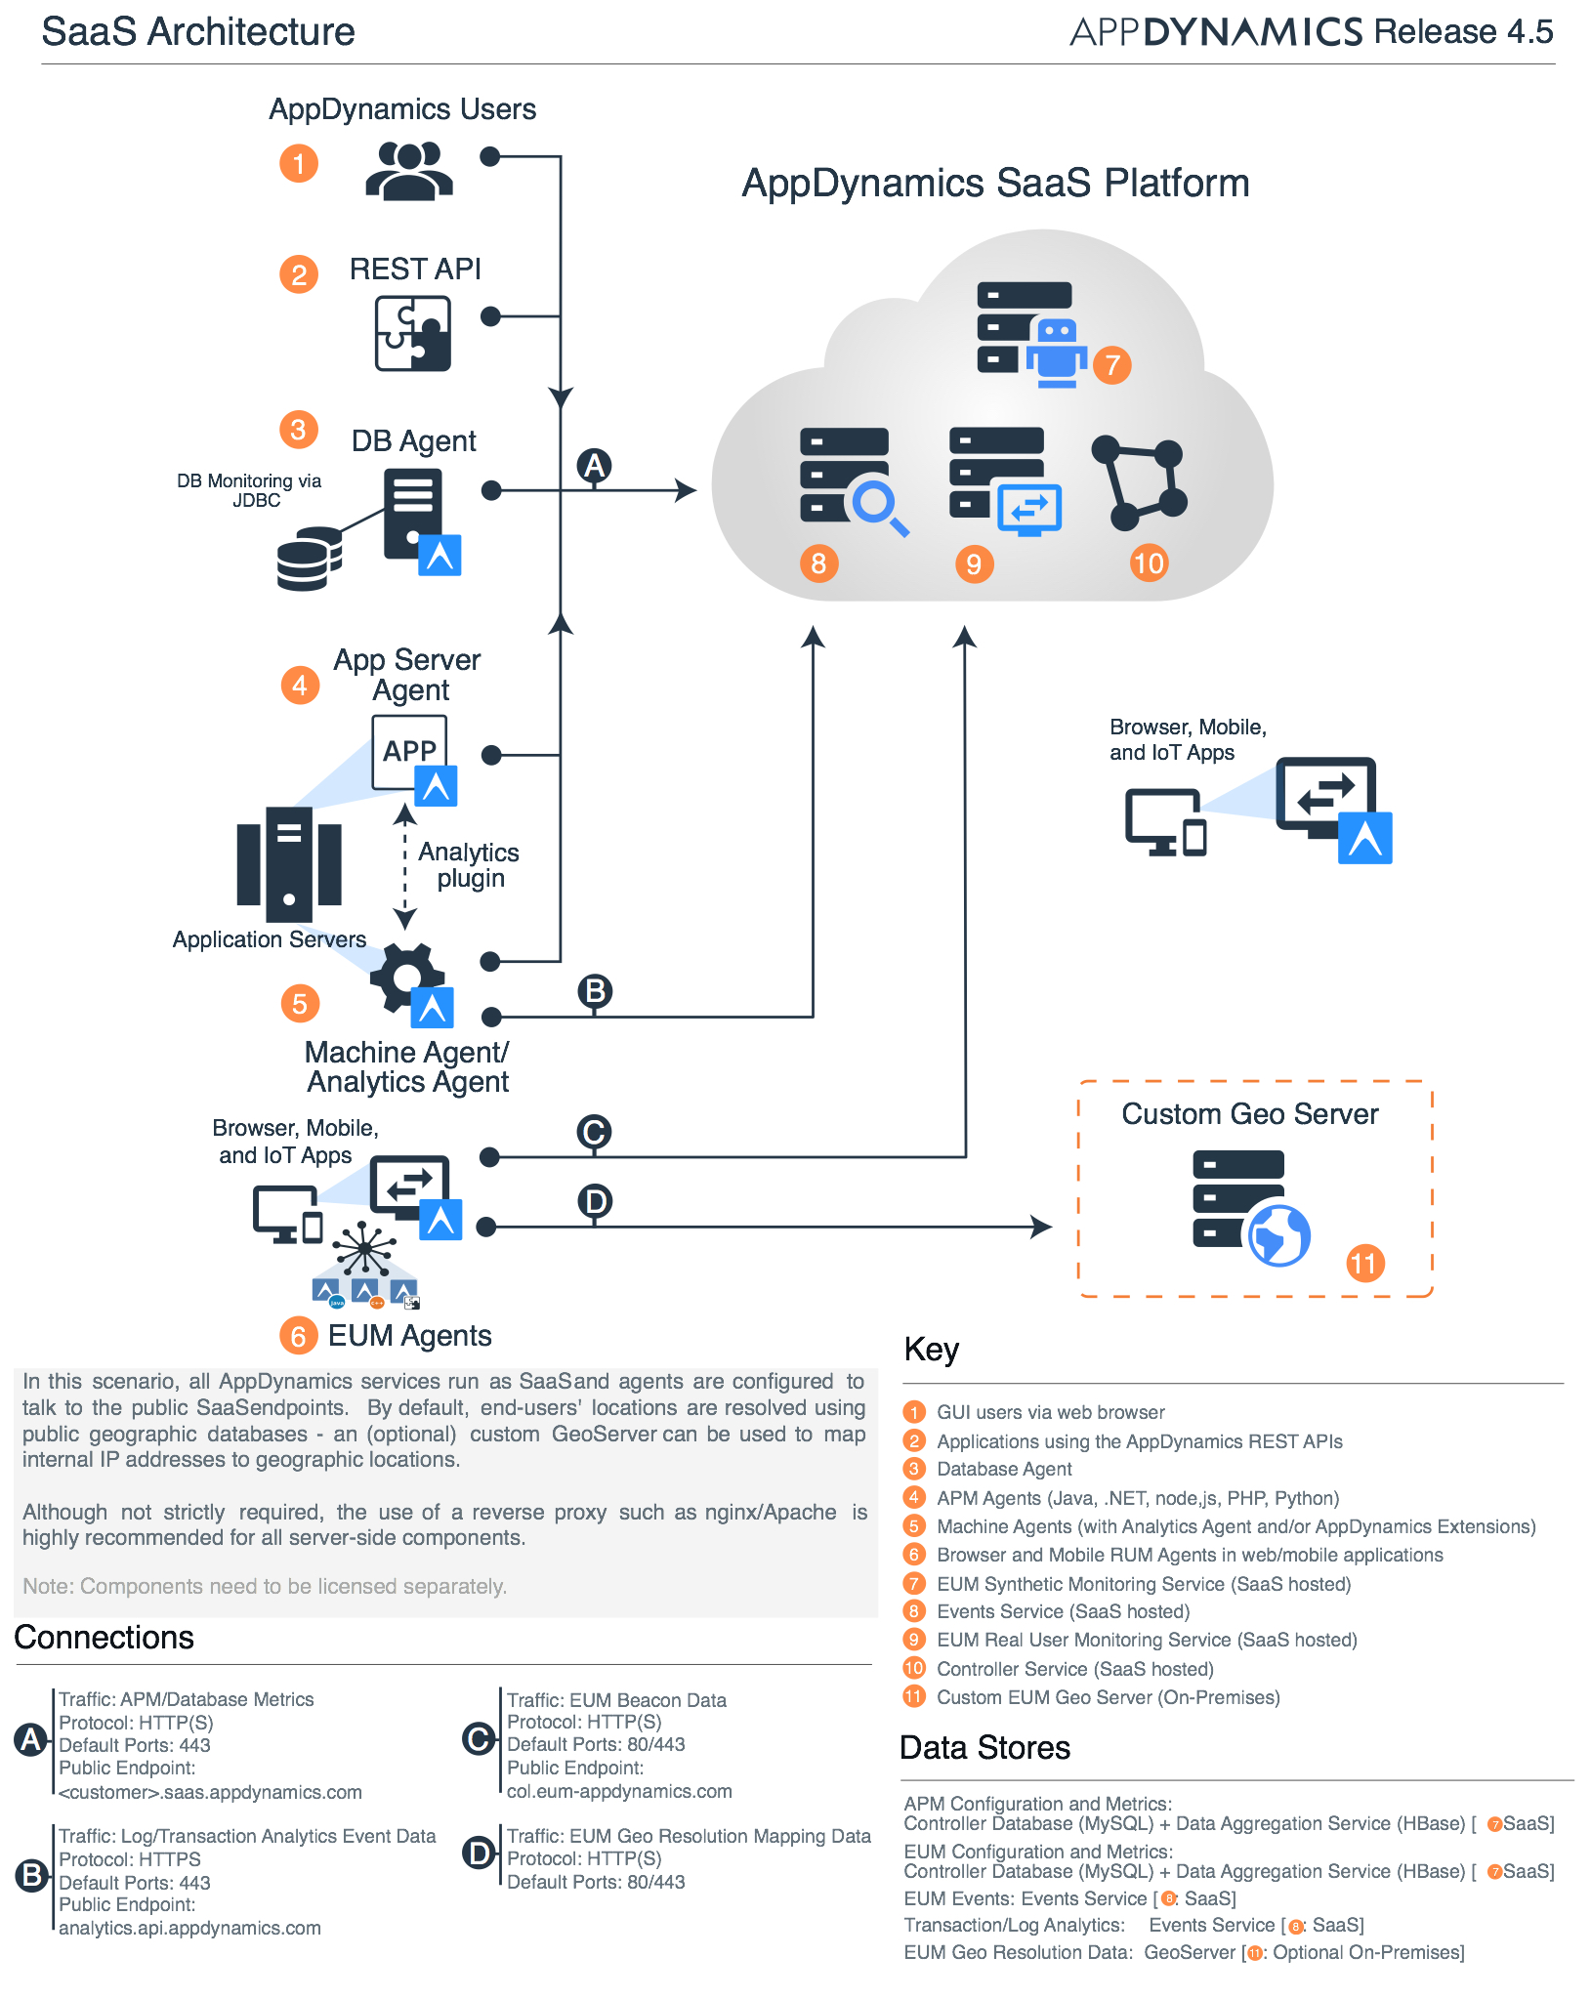

AppD Cloud:

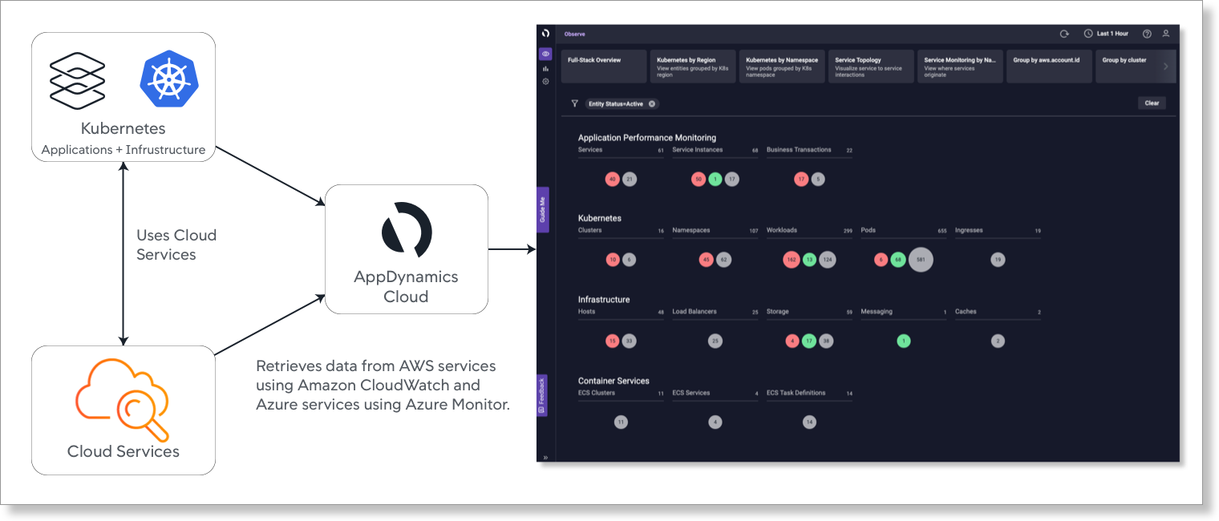

FSO Platform:

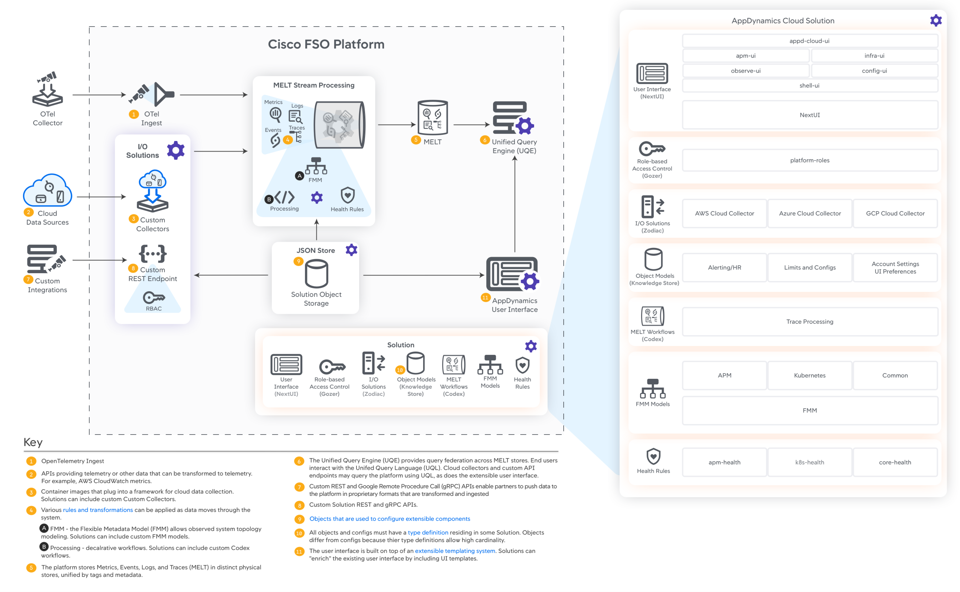

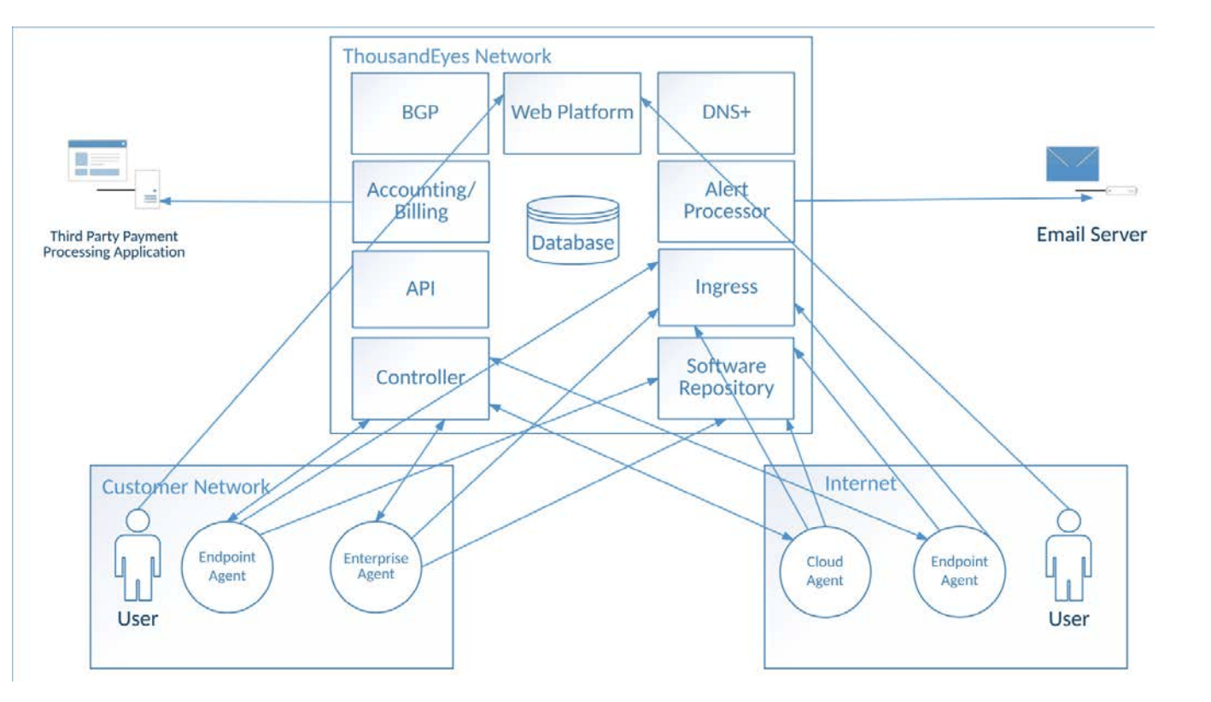

WHAT IT IS

High Level Design: Multi-cloud, hybrid-cloud System Context Diagram

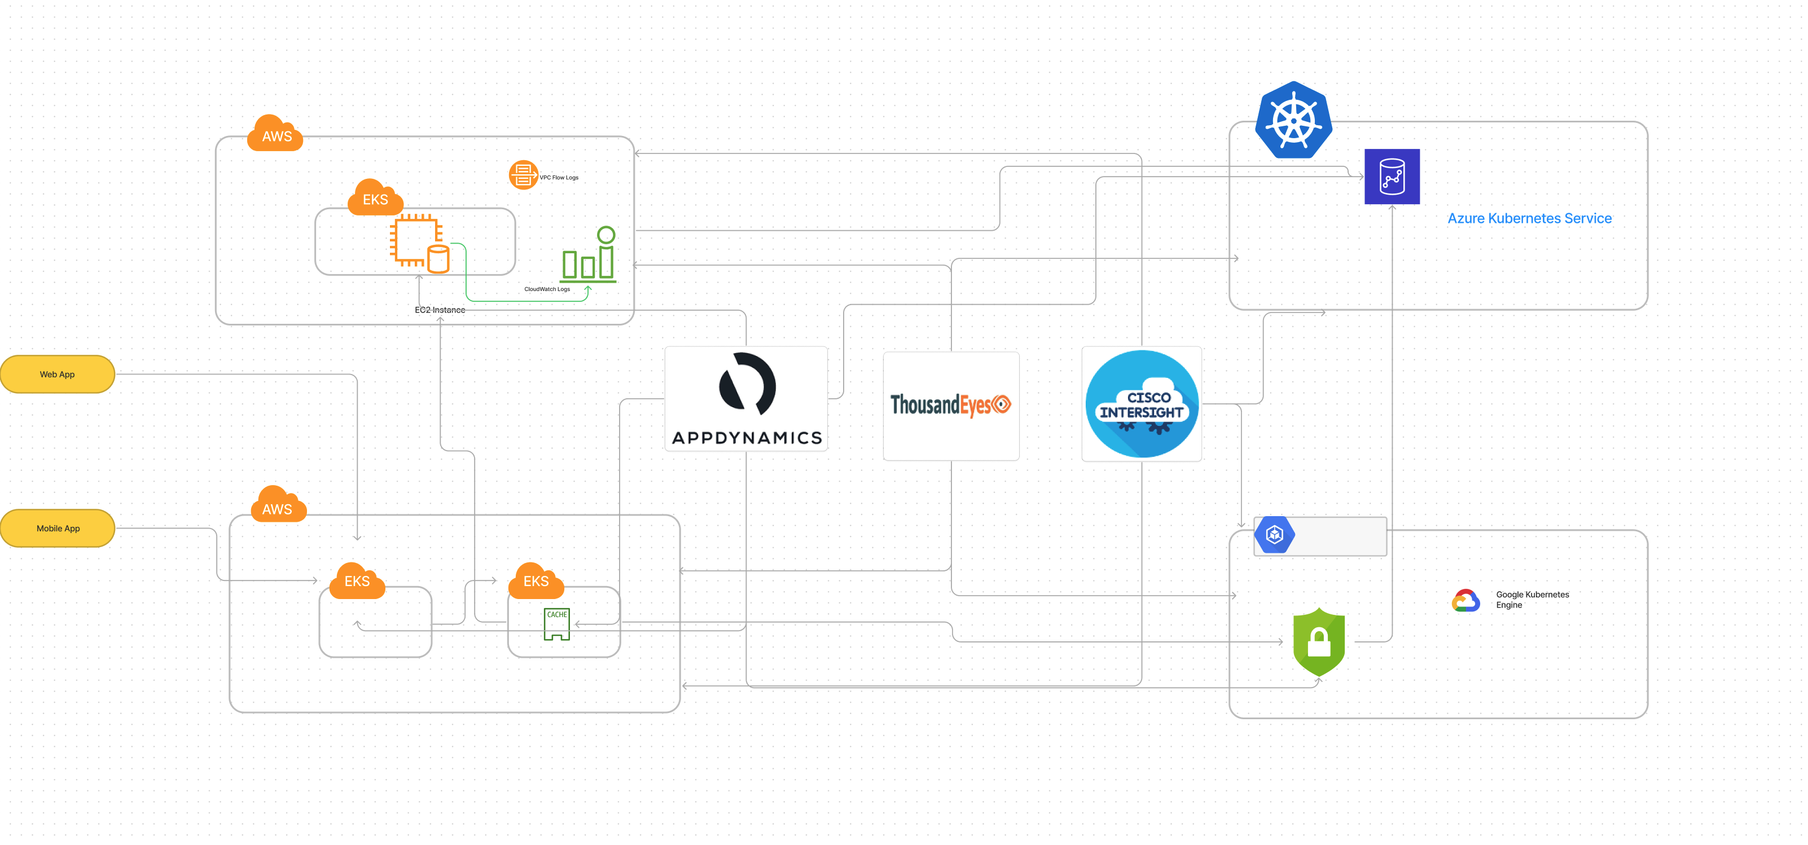

**Foundation Use Case Demo Application:**

Repurposing the Open Telemetry Astronomy eCommerce demo application into a self-service (Helm based) Cisco shopping cart application.

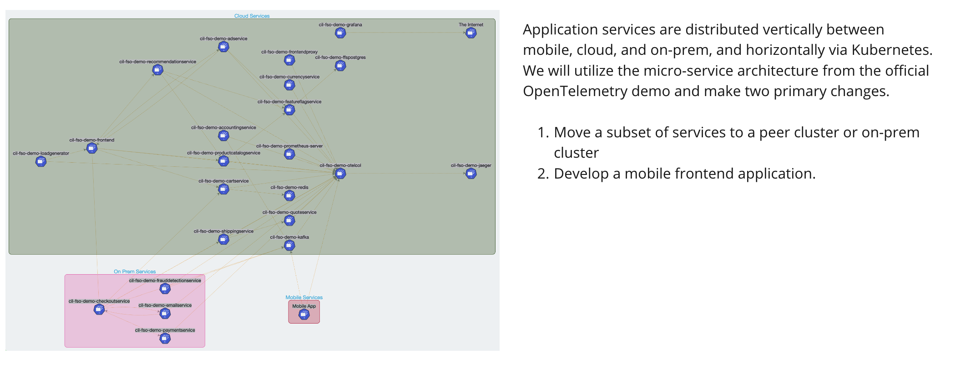OpenTelemetry Demo Service Topology:

* The plan is to create open-source CIL version of Open Telemetry demo application by replacing custom images and Labels.
* Invite contributor from AppD, TEs and IWO Team and other interested people.
* Design and deploy a mobile application which will use existing backend API.

<https://opentelemetry.io/docs/demo/architecture/>:

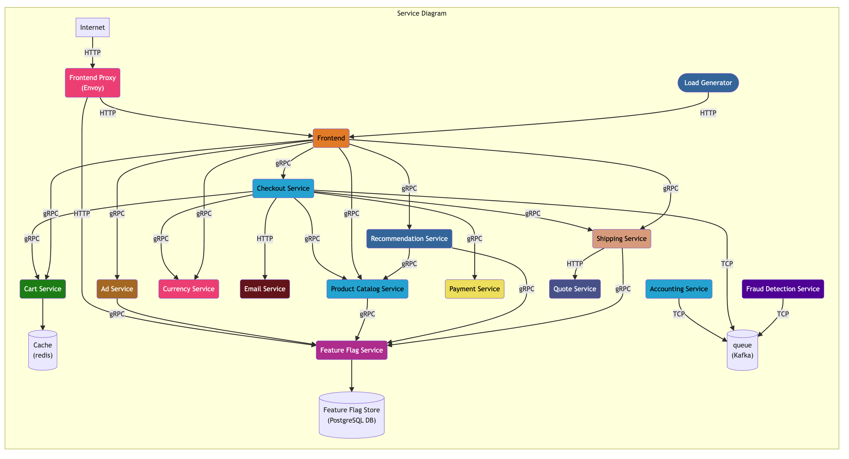

FSO Demo App Architecture:

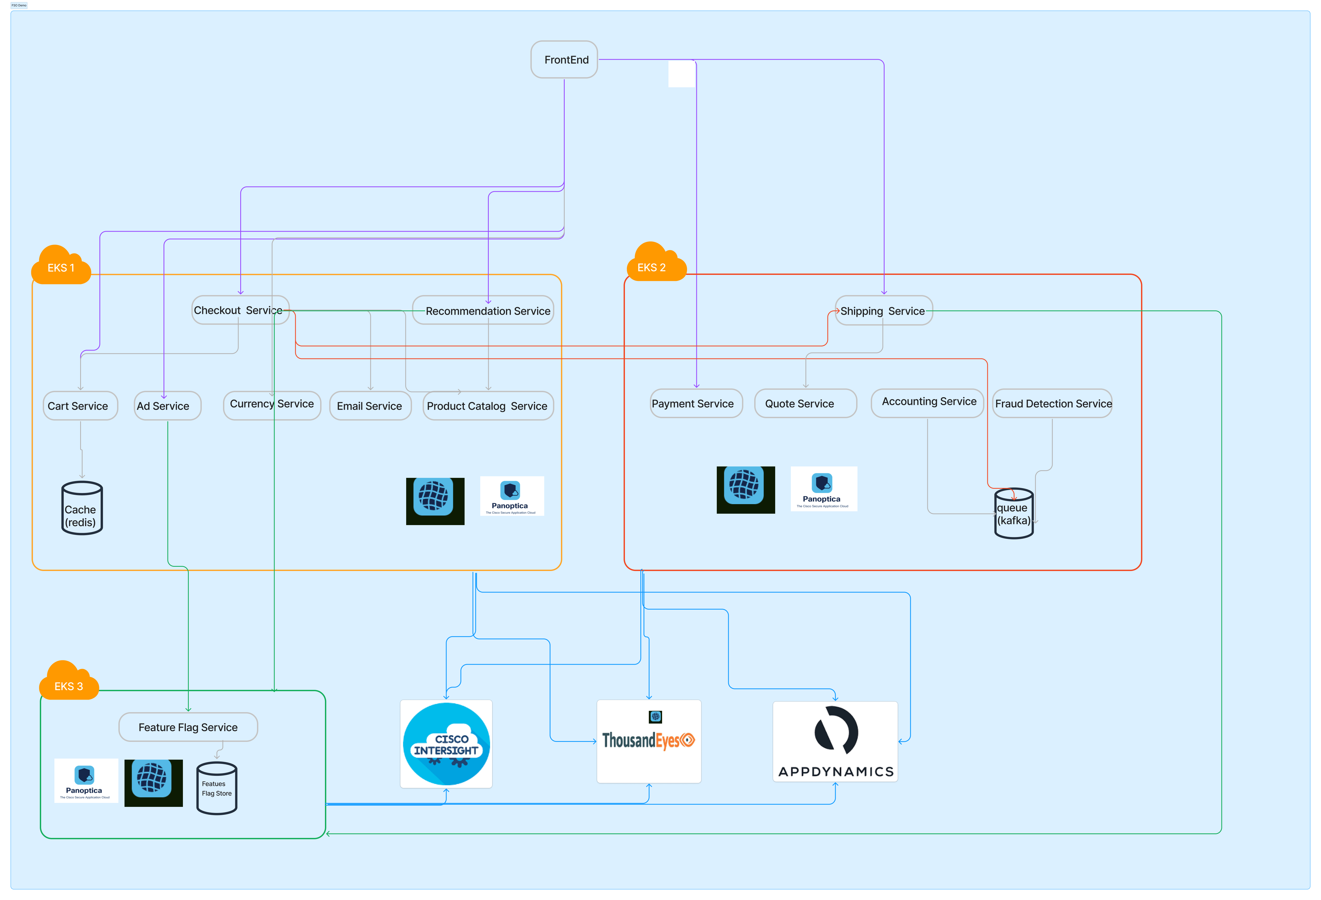

DEVELOPMENT:

|  |  |  |
| --- | --- | --- |
| Current FSO Demo/lab |  | Comment |
|  |  |  |
| dCloud | <https://dcloud2-lon.cisco.com/content/instantdemo/easy-experience-applications-securely-anywhere> | Self Services demo lab, Healthcare and Technology demo applicatoin |
| fsoLab | [https://www.fsolabs.net/ is using https://github.com/DescartesResearch/TeaStore for demo showcase](https://www.fsolabs.net/) | Partner Team run demo workshop using TeaStore application |
| AppD | https://github.com/Appdynamics/ot-sample-app | A Sample Micro service Application  with different instrumentation models  using AppD and OpenTelemetry |
|  |  |  |
|  |  |  |
| Open-source  /Community |  |  |
|  | <https://github.com/sherifadel90/AppDynamics-SupercarsJavaApp> | Struts application which provides for an online supercar store which  has some performance/code issues. The application can be built with Maven |
|  | <https://github.com/JPedro2/Cloud-Native-Demo> | Cloud-Native application with 10 microservices showcasing  Full-Stack Observability with Kubernetes, Istio, Kiali, AppDynamics and ThousandEyes |
|  | <https://github.com/flopach/thousandeyes-grafana-dashboard> | Extract data from ThousandEyes REST API and  visualize it on your customized Grafana Dashboard |
|  | <https://github.com/flopach/opentelemetry-appdynamics-demoapp> | This a sample weather app provides more insight into leveraging Open Telemetry (Otel). |
|  | <https://github.com/moskrive/FSO-with-CoolSox> | Demo Application used during TECCLD-2307 at Cisco Live EMEA 2023 |

Figure list of functionality like homepage, Cart page, Address and pricing page present in OTel demo(<http://a100c42fb7acf447caaf45c565b5ba43-439995579.us-east-2.elb.amazonaws.com:8080>).

We will utilize two versions of the OTel demo:

1. Modified code covering security, fault injection, and other observability or tool suggested changes

2. Stock OTel demo application

Our objective is to provide a comparative showcase of FSO+CN tools capabilities.

**Homepage**:

path: /

A showcase of featured products

Shopping cart widget

currency widget

Go Shopping button path: /#hot-products

**Product page:**

path: /product/{productID}

Detailed information about a specific product

Product images

Product description

Add to cart button

Related products

**Cart page:**

path: /cart

A list of all the items currently in the shopping cart

A subtotal and total cost of the items in the cart

An button to empty cart

A form for entering billing and shipping information

An button to Place Order

An Button to Continue Shopping

Related products

**Checkout page**

path: /cart/checkout/{order-ID}

A message "Your order is complete!", "We've sent you a confirmation email."

A List of items bought with shipping data and status

Related products

BILL OF MATERIALS

This BoM is meant for an estimation of what it takes to set up the entire demo if all cost would have to be considered.

1. Cloud Resources​
   1. 2x EKS Clusters (Using ETI-SRE environment - No Cost)
   2. Cisco Internal Cloud ​
   3. 1 GKS Cluster (Advance Use case)
   4. 1 Azure Cluster (Advance Use case)
2. Cisco Software Resources
   1. AppD Cloud – Need to buy License ​– Multi Cluster
   2. ThousandEyes – Need to buy License- Multi Cluster
   3. IWO – Need to buy License – Multi cluster
   4. Callisti (Free tier – Need to buy License for Advance User Case)​
   5. Panoptica

|  |  |  |  |  |  |  |
| --- | --- | --- | --- | --- | --- | --- |
| Part Number | Nº | Cost per Licensing -12 | Cost per Licensing-24 | Licensing Unit | Cost 12 per months | Cost per 24 months |
| APPD-EN-C | 40 | 90 | 90 | Per License( vCPU)/Month | 43200 | 86400 |
| APPD-CLOUD-ING | 40 | 25 | 25 | Per License(Token)/Month | 12000 | 24000 |
| APPD-SA-PR-C-I | 40 | 27.50 | 27.50 | Per License( vCPU)/Month | 13200 | 26400 |
| DC-MGT-WO-SAAS-AD | 20 | 17.53 | 15.77 | Per Virtual Machine/Month | 4207.2 | 7569.6 |
| ETI-CALISTI-ENT | 25 | 49.58 | 44.63 | Per Node/Month | 14874 | 26778 |
| ETI-SAESSCONT-ENT | 10 | 114.58 | 103.13 | Per Node/Month | 13749.6 | 24751.2 |
| SVS-APPD-SUP-B | 1 | 0 | 0 | Per Each/Month | 0 | 0 |
| SVS-DCM-SUPT-BAS | 1 | 0 | 0 | Per Each/Month | 0 | 0 |
| SVS-TE-SUP-B | 1 | 0.00 | 0 | Per Each/Month | 0 | 0 |
| TE-INSIGHTS | 1 | 2,775.00 | 2,775.00 | Per License/Month | 33300 | 66600 |
| TE-USERS | 100 | 14.60 | 14.60 | Per User/Month | 17520 | 35040 |
| Total |  |  | Lead Time | 21 days | $152,050.80 | $297,538.80 |
| Final Price |  |  | Discount | 83% | $25,849.2 | $50,581.60 |

Table: Detailed BOM with prices.

https://apps.cisco.com/ccw/cpc/estimate/open/DA142297882NL

POTENTIAL ROADMAP FOR DELIVERY

**Mockup**

Customized and branded OTel demo web application.

Acquire working knowledge of all 3 FSO tools.

**Alpha**

Run all 3 FSO tools on EKS cluster with customized OTel demo application.

Define 3 Hour, 3 Week, 3 Month engagement model plan for FSO demo application.

**Beta**

Implement Chaos engineering in demo application.

Inject random fault in code by failing 2 out 10 requests using hardcode exception in service call.

**Available**

* + Refined implementation of dashboard prototype ready for customer demonstration

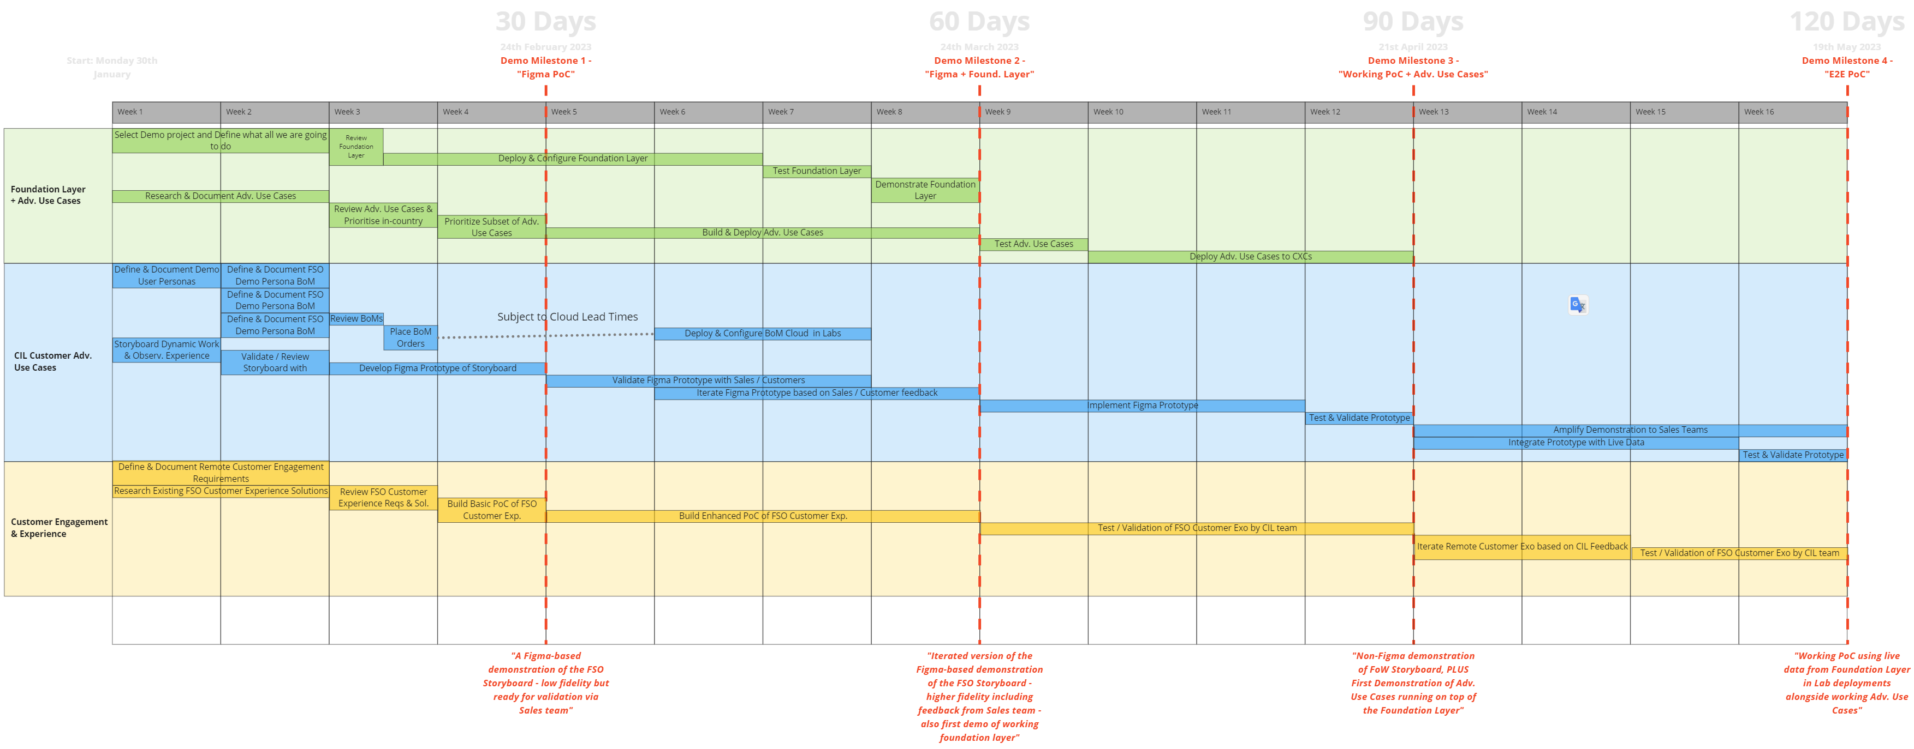

UNHAPPY SCENARIOS

Our Demo may not deliver on what the sales team expect us to show in a customer interaction.

We can avoid this Unhappy Scenario:

**Define goals**: Clearly define the goals of the demo and what needs to be shown in the interaction. This should be based on the needs and expectations of the customer and the objectives of the interaction.

**Gather requirements**: Gather the requirements for the demo from the sales team, stakeholders, and customers. This will help ensure that the demo covers all the necessary areas and addresses the customer's needs.

**Create a plan**: Create a plan for the demo that covers all the requirements and meets the defined goals. This plan should be reviewed and approved by the relevant stakeholders.

**Prepare the demo**: Prepare the demo based on the approved plan, making sure it accurately represents the product and its capabilities. This should include testing and debugging to ensure the demo works as intended.

**Schedule a dry run**: Schedule a dry run of the demo in a simulated customer interaction environment. This will give an opportunity to identify any issues and make any necessary adjustments before an actual customer interaction.

**Rehearse**: Rehearse the demo several times to ensure that the demo is well-prepared and the sales and account teams are confident in the delivery.

**Evaluate**: After the sales meeting, evaluate the demo and consider feedback from the sales team, stakeholders, and customers. Use this feedback to make any necessary improvements for future sales meetings.

RISKS

As of now we don’t know what all kind of demo is present with in cisco boundary and we are talking to various sales, partners, cx and product team to know existing set of demos and there is possibility of redundant work.

We know very little about TEs and IWO so it might delay us.

There 3 products are complex and if we get stuck somewhere and didn’t get timely support then it could delay our planned delivery and tell a cohesive story

SPONSORS/STAKEHOLDERS

CIL

John Parello

Cisco Sales

* Need to figure out

Cisco Product Teams

* Need to figure out

Cisco Engineering

Reviewers (proposed, not finalized yet, still collecting names)

* Carlos Pereira, Fellow & Chief Architect, ET&I
* Renato Quedas, PE, AppDynamics R&D
* Tim Szigeti, Director Technical Marketing, ET&I

Identify Someone from CFG team https://cisco.sharepoint.com/sites/CompetitiveFieldGuides/SitePages/FSO-Field-Guide.aspx

|  |  |
| --- | --- |
| **Phases** | **Reviewers** |
| Content/Planning | Carlos Pereira, Fellow & Chief Architect, ET&I  Tim Szigeti, Director Technical Marketing, ET&I |
| Mockup | Renato Quedas, PE, AppDynamics R&D  Anuj Modi, TSA  David Liebman, TSA  Vijay Tandon, BFSI SE Leader |
| Alpha |  |
| Beta |  |
| Release |  |

APPENDIX

Proposed Team

Based on the above high-level design and requirements, it is anticipated that we shall need the following:

* Subject Mater Expert of FSO Tools (AppD, ThousandEyes, Intersight Workload Optimizer) for Reviewing and validation.
* All In-country leads for testing plus customer / sales feedback loop.

|  |  |
| --- | --- |
| **Phases** | **Proposed Team** |
| Content/Planning | Keshav Kumar  Cody Kai Hartsook  Lucas Barboza  Leandro Schwab Dias Carneiro |
| Mockup | Felix Kaechele  Brianna Gilchrist  Keshav Kumar  UX Designer |
| Alpha | Felix Kaechele  Cody Kai Hartsook  Leandro Schwab Dias Carneiro  Brianna Gilchrist  Keshav Kumar  Jyoti Chaturvedi  SRE Engineer (Extended support) |
| Beta | Felix Kaechele  Cody Kai Hartsook  Leandro Schwab Dias Carneiro  Brianna Gilchrist  Keshav Kumar  Jyoti Chaturvedi |
| Release | Felix Kaechele  Jyoti Chaturvedi |

References:

<https://cisco.sharepoint.com/sites/CompetitiveFieldGuides/SitePages/FSO-Field-Guide---Datadog.aspx#technical-insights%E2%80%8B%E2%80%8B%E2%80%8B%E2%80%8B%E2%80%8B%E2%80%8B%E2%80%8B%E2%80%8B%E2%80%8B%E2%80%8B%E2%80%8B%E2%80%8B%E2%80%8B%E2%80%8B>

<https://cisco.sharepoint.com/sites/CX_TTG_Amer_Communications/Shared%20Documents/Forms/AllItems.aspx?id=%2Fsites%2FCX%5FTTG%5FAmer%5FCommunications%2FShared%20Documents%2FIBN%20Documents%2FThousand%20Eyes%2Fcisco%2Dthousandeyes%2Dsecurity%2Dbrief%2Epdf&parent=%2Fsites%2FCX%5FTTG%5FAmer%5FCommunications%2FShared%20Documents%2FIBN%20Documents%2FThousand%20Eyes>

https://www.figma.com/file/RQfwxAVgjpkrhCWoNxmDSu/FSO-Architecture?node-id=0%3A1&t=r01QpZPNqpjwP2y1-0